using System;

using System.Collections.Generic;

using System.Linq;

using System.Text;

namespace ConsoleApplication26

{

public class MyClass

{

// Static variable

private static int staticVariable = 0;

// Non-static variable

private int nonStaticVariable;

// Constructor

public MyClass(int value)

{

nonStaticVariable = value;

}

// Static method

public static void StaticMethod()

{

Console.WriteLine("This is a static method.");

Console.WriteLine("Static variable value:" +staticVariable);

}

// Non-static method

public void NonStaticMethod()

{

Console.WriteLine("This is a non-static method.");

Console.WriteLine("Non-static variable value: " +nonStaticVariable);

}

}

class Program

{

static void Main(string[] args)

{

// Create instances of MyClass

MyClass obj1 = new MyClass(10);

MyClass obj2 = new MyClass(20);

// Call static method

MyClass.StaticMethod();

// Call non-static method

obj1.NonStaticMethod();

obj2.NonStaticMethod();

Console.Read();

    }

}

}

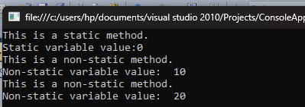

//Extended method

using System;

using System.Collections.Generic;

using System.Linq;

using System.Text;

namespace ConsoleApplication25

{

class Emp

{

public int getID()

{

return 1206;

}

public void getName(String s)

{

Console.WriteLine("Name:" + s);

}

}

static class EmpExtended

{

public static void getDept(this Emp e) // extension method to Emp class

{

Console.WriteLine("Dept: Marketing");

}

public static void getnetsal(this Emp e)

{

int sal = 10000;

int ysal = sal \* 12;

int netsal = ysal + ((ysal \* 10) / 100);

Console.WriteLine("Net salary of Employee: " +netsal);

}

}

class Program

{

static void Main(string[] args)

{

Emp e = new Emp();

Console.WriteLine("Emp id:" + e.getID());

e.getName("Sam");

e.getDept();// Extension method /

e.getnetsal();

Console.Read();

}

}

}

